**A PROJECT REPORT ON**

**EV MODEL**

Course Title: System Integration with Dymola

Course Code: CUTM1022 (0-0-2)

*Submitted to:*

*Dr. Sudhansu Kumar Samal*

*Faculty of*

*School of Engineering & Technology, Bhubaneswar*

*in partial fulfilment for the award of the*

*degree of*

**CENTURION UNIVERSITY OF TECHNOLOGY & MANAGEMENT**

**2021-2024**

**Submitted by:**

Name: Kiran Kumar Malik

Registration no: 200301120128

Branch: B-Tech in Computer Science and Engineering’s

Semester: 4th Sem

Section: C

Inside the package EV_project create a new package as EV_model. In this package, create a new class within it naming it EV1.

Go to Modelica packages, then drag and drop the components for EV1: PropDriver, Torque, Inertia, Ideal Gear, Ideal Rolling Wheel, Mass, VelSens, Drag Force.

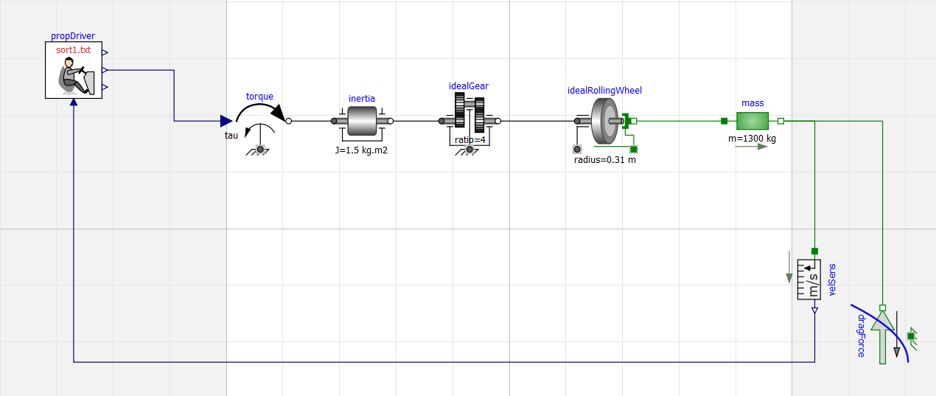

Save the file before simulation and after completing the circuit so as to avoid error.

Then check it once by clicking on the check box.

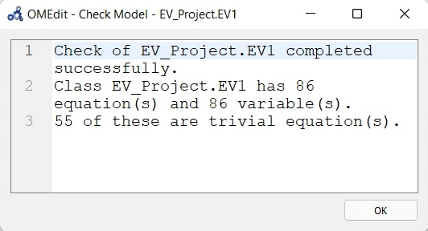

Then you can do the simulation to get the graph. The graph changes according to the variables changed.

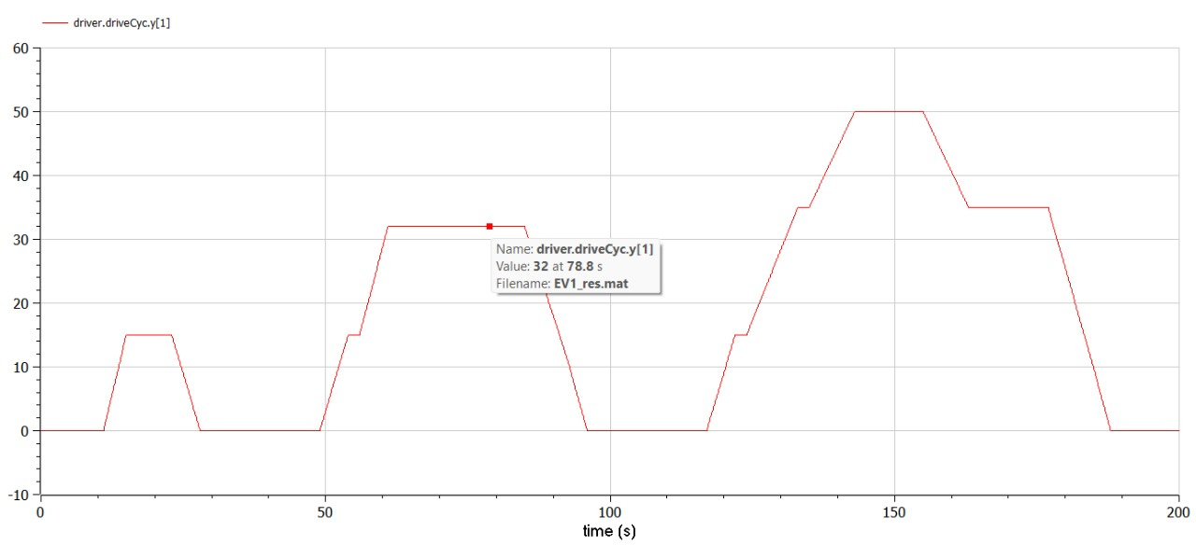

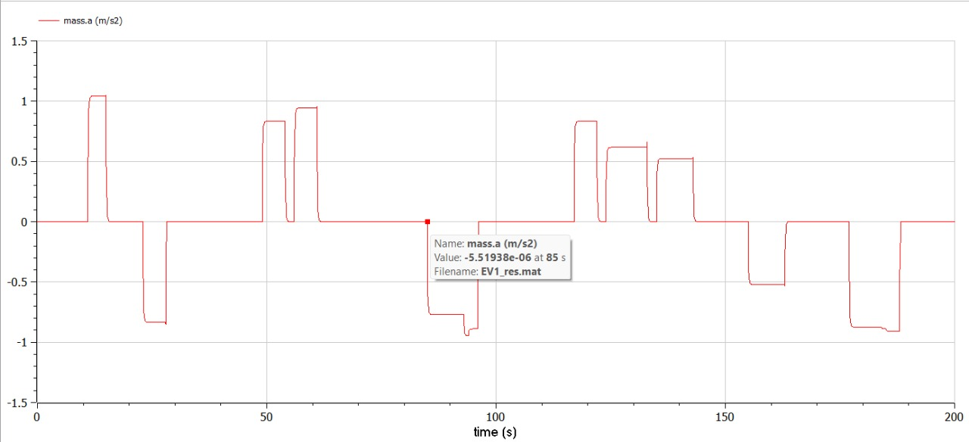

Inside the package EV_project create a new package as EV_model. In this package, create a new class within it naming it EV2.

Go to Modelica packages, then drag and drop the components for EV2: PropDriver, Torque, Inertia, Ideal Gear, Ideal Rolling Wheel, Mass, VelSens, Drag Force, Power Sensor1, Power Sensor2.

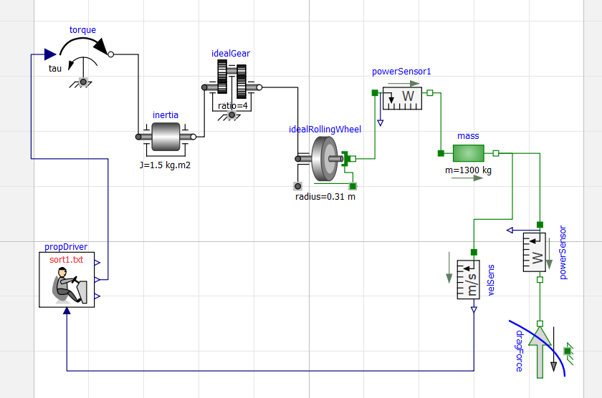

Save the file before simulation and after completing the circuit so as to avoid error.

Then check it once by clicking on the check box.

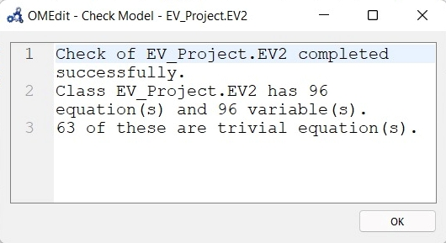

Then you can do the simulation to get the graph. The graph changes according to the variables changed.

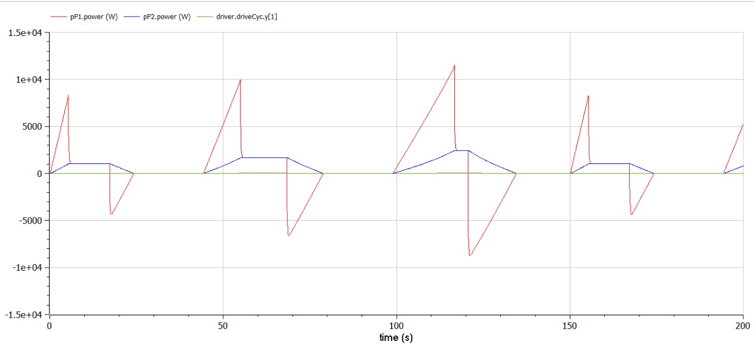

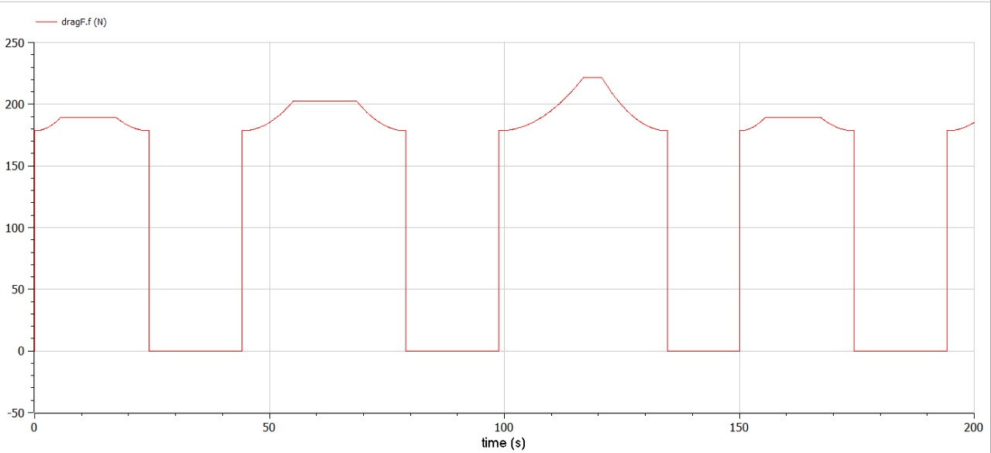

Inside the package EV_project create a new package as EV_model. In this package, create a new class within it naming it EV3.

Go to Modelica packages, then drag and drop the components for SIMPLE_EV: PropDriver, Torque, Inertia, Ideal Gear, Ideal Rolling Wheel, Mass, VelSens, Drag Force, Data.

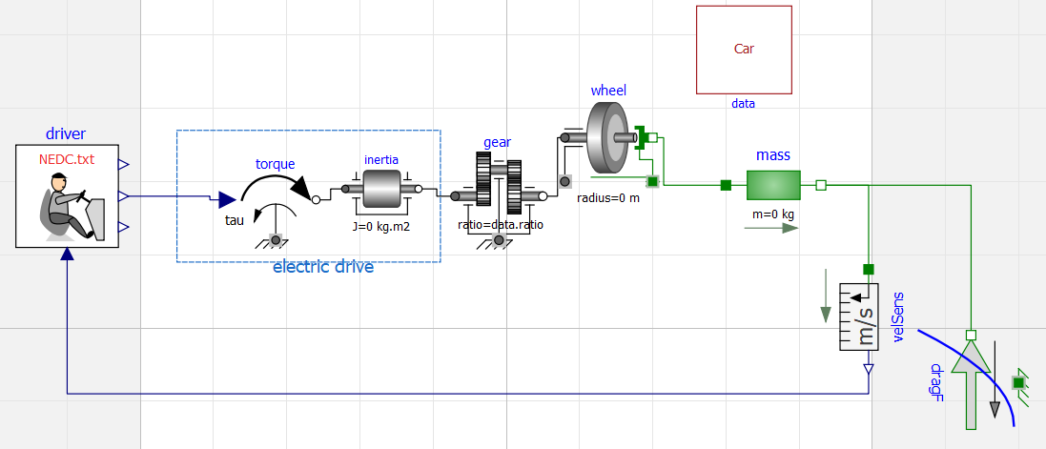

Save the file before simulation and after completing the circuit so as to avoid error.

Then check it once by clicking on the check box.

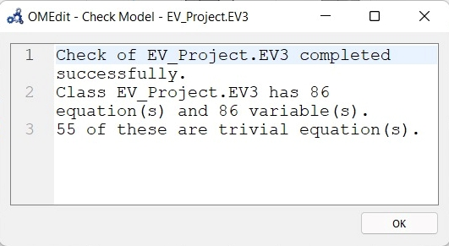

Then you can do the simulation to get the graph. The graph changes according to the variables changed.

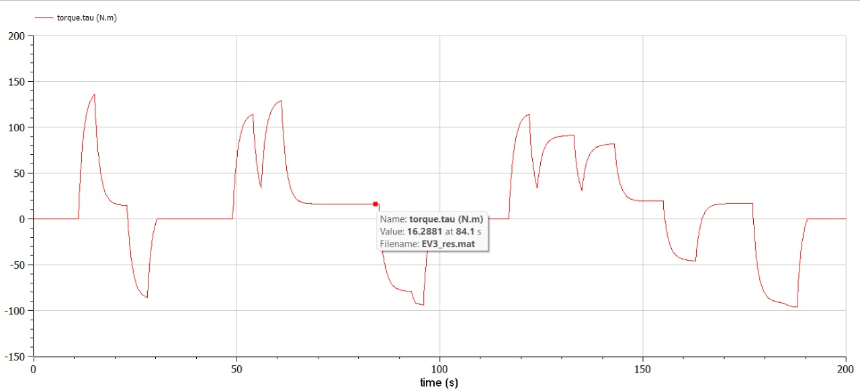

Inside the package EV_project create a new package as EV_model. In this package, create a new class within it naming it EV4.

Go to Modelica packages, then drag and drop the components for EV4: PropDriver, Battle1, One Flange, Ground, Torque Sensor, Inertia, Ideal Gear, Ideal Rolling Wheel2, Mass, Drag Force, Power Sensor, Power Sensor2, Speed Sensor, Force, Gain, Limiter, Add.

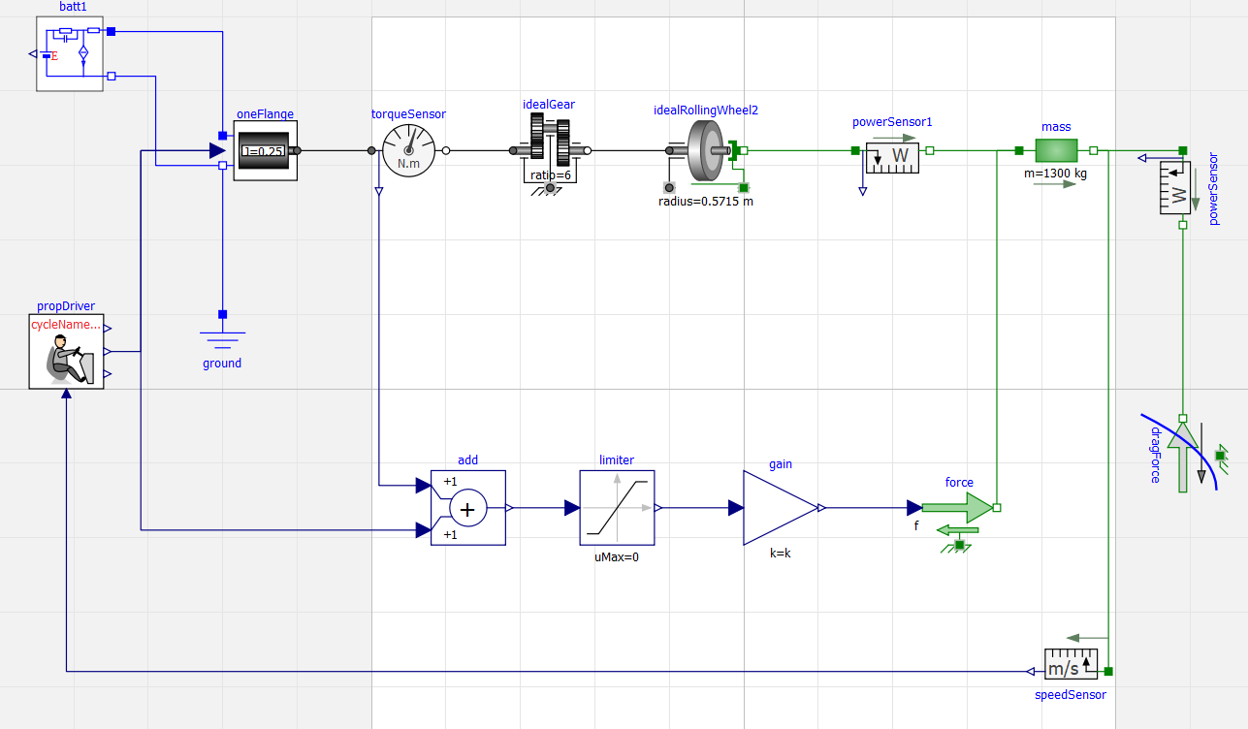

Save the file before simulation and after completing the circuit so as to avoid error.

Then check it once by clicking on the check box.

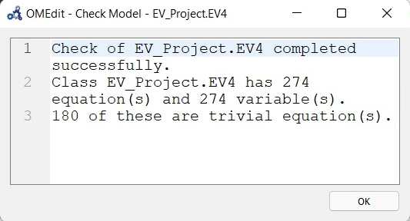

Then you can do the simulation to get the graph. The graph changes according to the variables changed.

This particular graph contains the battery Stat-of-charge (SOC)

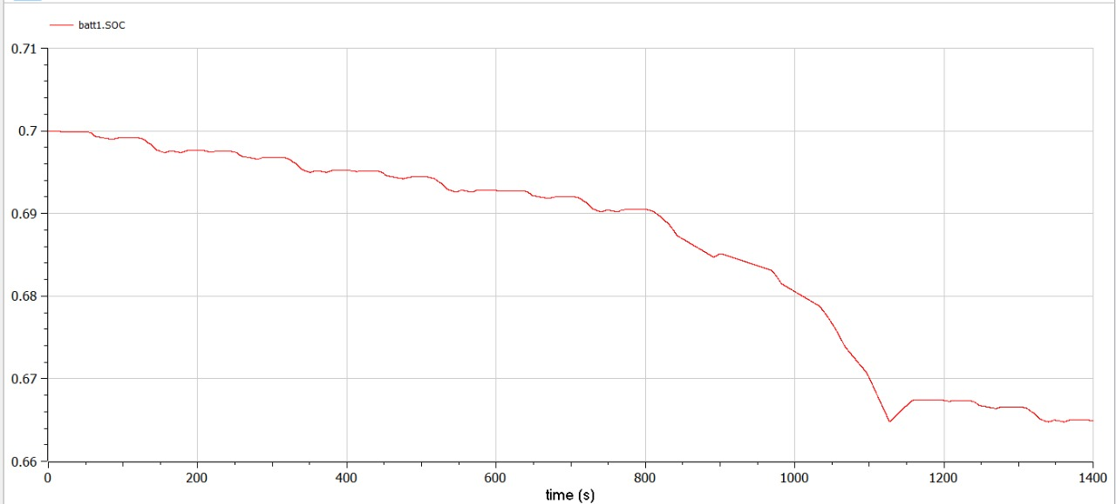

This particular graph compares actual (blue) and desired speed, and shows that they are very near to each other.

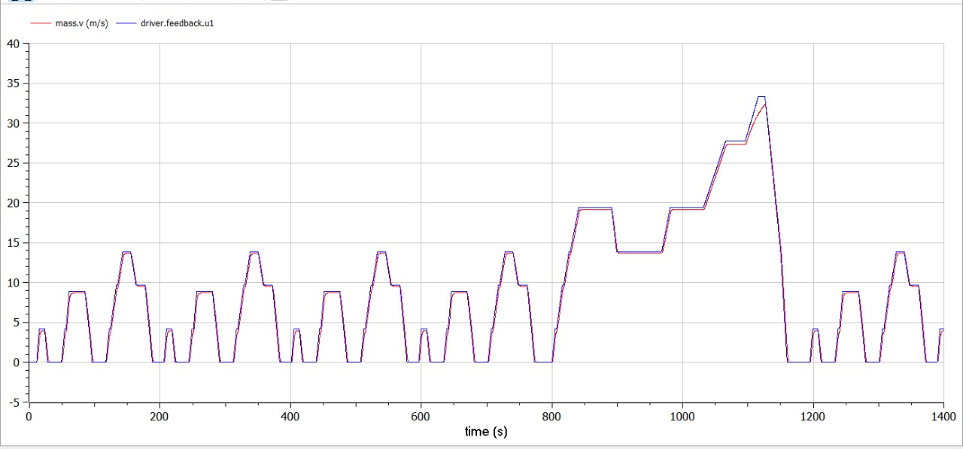

This particular graph contains the battery voltage.

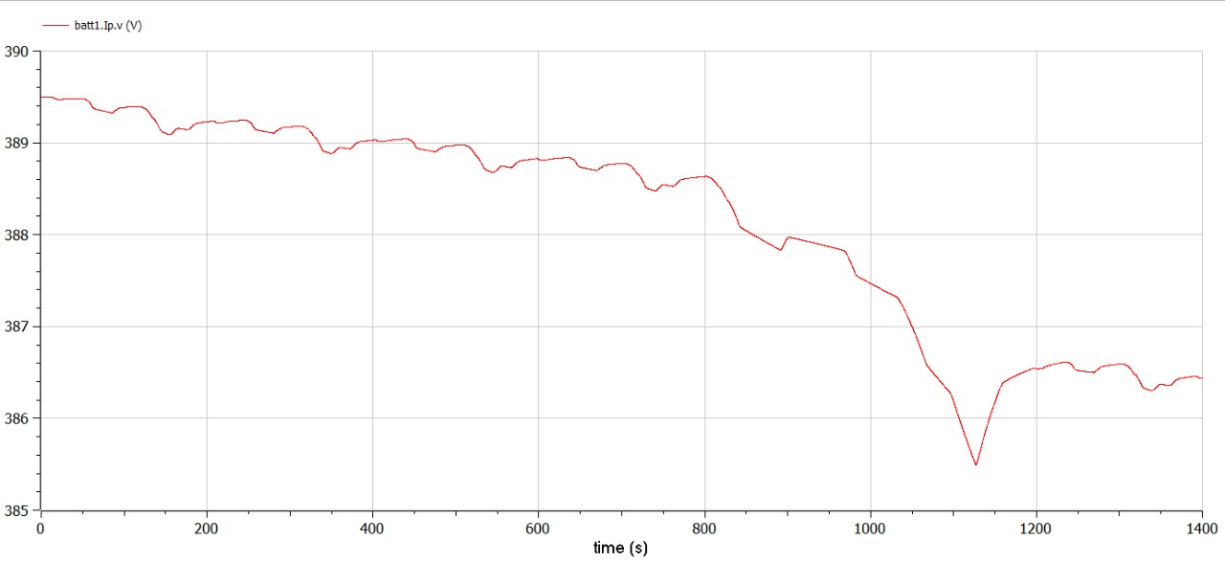

This particular graph shows energies. In this case energies are obtained using direct equation writing, to avoid the diagram to become too crowded.

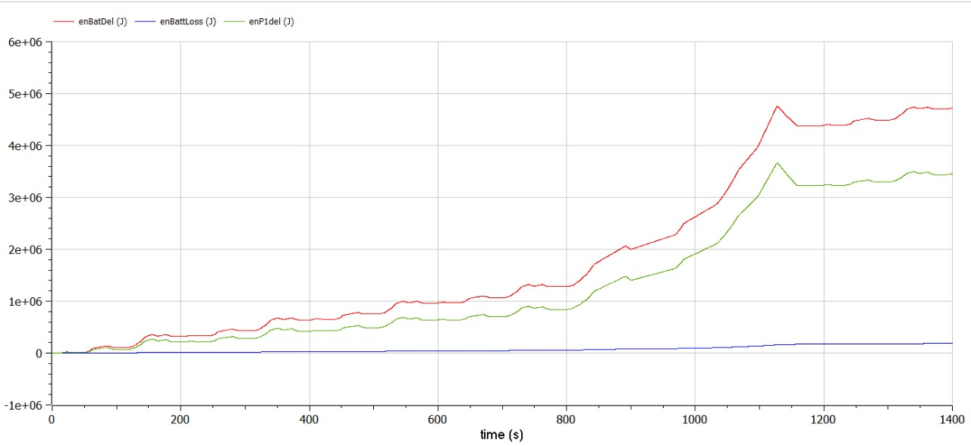

This particular graph show torque request (blue), torque delivered by the electric drive (red) torque corresponding to the mechanical braking force (blue).

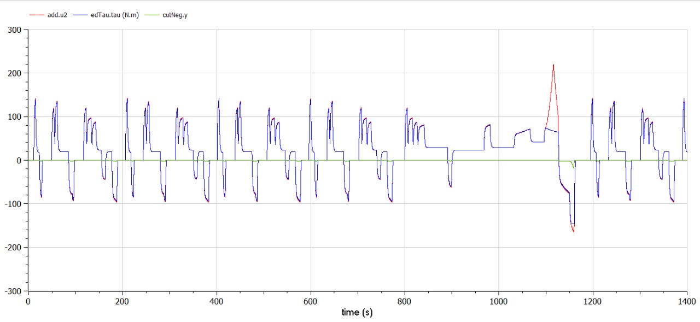

This braking energy is compared with pP1 energy.

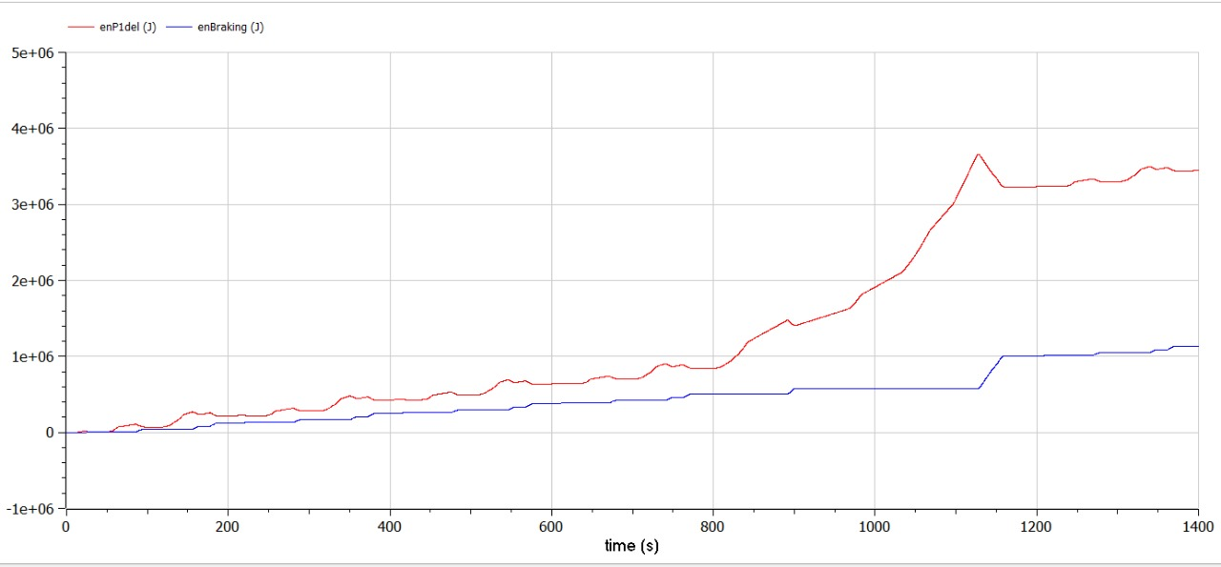

Signature of Faculty Signature of Student